**BME802 – Human Computer Interaction**

**LAB REPORT**

|  |  |
| --- | --- |
| **Semester/Year:** | Winter 2024 |
| **Lab Number:** | 4 |
| **Lab Title:** | Website Usability Testing |

|  |  |
| --- | --- |
| **Instructor:** | Kristiina Mai |
| **Section No:** | 02 |
| **Submission Date:** | April 3, 2024 |
| **Due Date:** | April 4, 2024 |

|  |  |  |
| --- | --- | --- |
| **Student Name** | **Student ID** | **Signature** |
| Zulfa Varvani | 500951166 | Z.V. |

By signing above you attest that you have contributed to this written lab report and confirm that all work you have contributed to this lab report is your own work. Any suspicion of copying or plagiarism in this work will result in an investigation of Academic Misconduct and may result in a 0 on the work, an F in the course, or possibly more severe penalties, as well as a Disciplinary Notice on your academic record under the Student Code of Academic Conduct, which can be found online at: [www.ryerson.ca/senate/current/pol60.pdf](http://www.ryerson.ca/senate/current/pol60.pdf).

**Results:**

*Part A*

1. Zulfa’s Food Blog: <http://localhost:3000/>
2. The purpose of this site is to provide recipes with step-by-step instructions in a simple manner while also giving historical context into the recipes. This site is for those interested in learning different cultures and trying out new simple dishes without having to go to fancy restaurants! Its main purpose is to shed light on unique backgrounds while also inviting newcomers, driving unity and understanding of these cultures.
3. I chose React to build my website and used Typescript to code out the whole site (using MUI components as well). I chose this tool as I enjoy coding and creating my own website under my own terms rather than using drag-and-drop tools where I’m limited to what I can do with my website. The pros are the above, with the flexibility to manage how my site will look and also gives me a more in-depth understanding of how websites are really designed. The cons are that it was time-consuming to create the pages and components, while drag-and-drop website-makers are more intuitive and quicker to design with ready-made components. In addition, website hosting or sharing the website link with others is another task/issue that comes with developing a website from scratch.
4. Questions to ask evaluator:
   1. When entering the site, are the goals/objective met? I.e. would you feel that you could easily make a dish from the website and also learn from the recipe historical context?
   2. Is the colour scheme/visuals used in this website appealing or enhancing for the purpose of the website?
5. Characteristics:
   1. Is the purpose of the site indicated on the home page? 🡪 In my website, I had my purpose included in the home page as I wanted the context of the creation of the site known as soon as the user accesses the site as I found the purpose and inspiration very important.
      1. Some websites that are financially-related or e-commerce-related place their purpose statement in tertiary areas or pages of their website as they expect the website to already have implied the purpose (like Nominal)
      2. Some websites that users would use to do quick, creative work (like Canva) or tools that make manual searching tasks simpler (like online citation machines) also don’t place their mission statement at all on their websites as users would hardly check the purpose statements, directly using the website tool as the purpose is already implied.
   2. Are graphics/pictures added to the page? 🡪 my website did have quite a few graphics, each specific to its own country/region and each for its own recipe. When trying a new dish, it is important to place pictures relevant to the food so users are able to view what the dish should result in. Oftentimes, some websites have pictures for each step, but my website is meant to have clear, concise recipes (that I’ve tested out myself) that a user can follow without step-by-step pictures.
      1. Academic journals or content online would not put as much graphics as textual content would be the main objective, instead displaying information through charts and tables if needed. Graphics would distract readers and researchers from the analysis and research presented.
      2. Pages like governmental websites or tax form websites would not use graphics or pictures as the content would be highly sensitive or the purpose is to provide legal information/resources. Graphics and pictures would take away from the information and may confuse the user.
   3. Support and assistance must be available to help or correct any mistake 🡪 my website includes a contact me page as well as contact information at the footer. This is so users are able to contact support for any recipes, add recipes, or fix any recipes/information on the website.
      1. In informative websites where information is factual and cannot be changed, there would be no need to have a support or correction option. This would be in governmental websites where users would rely on the information presented and cannot change/have an input. Although they may have contact information, they would not have a support/assistance directly available on the site
      2. Research articles or online news sites would likely not have support/assistance available on the site as information is also factually based and cannot be changed, or would be expensive to change in the case of news sites. Information is already published.

*Part B*

Name: Zulfa (reviewing Sabrina Saiphoo’s website)

1. Video attached to submission
2. The website is related to mental health and wellbeing and reducing stress using different techniques. With the colour schemes used and the pictures, the website definitely is appropriate/relevant in relaying that purpose. All pictures used were relevant to the presented information in each page designed.
3. Positive:
   1. The colour schemes were very well chosen as they made the website look more “calming” and uniform  
      A screenshot of a website

      Description automatically generated  
      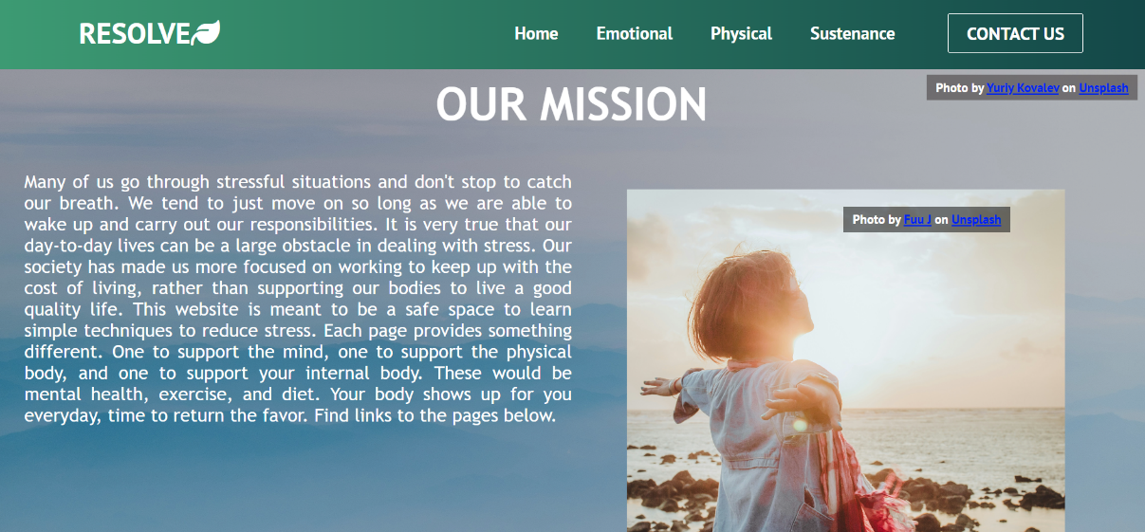
   2. The information and pictures placings were well-thought for an average user, and made the website look clean, without having too much or too little words.  
      A screenshot of a website

      Description automatically generated  
        
      A screenshot of a video

      Description automatically generated

Negative:

1. The font sizes used were too large for an average user entering the website  
   A screenshot of a computer

   Description automatically generated
2. The footer of the website could use more information, like contact information, rather than just the website name and copyright logo  
   A screenshot of a computer

   Description automatically generated
3. As there were buttons for navigation to other pages at the bottom of the home page and the top navigation bar, with both the navigation button areas being laid horizontally, a head-tracking control might be more difficult to select the buttons and may result in inaccurate button clicks. For headtracking mouse control, it would be more appropriate to use vertically aligned buttons (stacked on top of each other). Providing this dual stacking/positioning might allow for more non-traditional interfaces. The website is touch screen compatible, but on a mobile device, it would be more appropriate to line items stacked vertically rather than placed side-by-side as in the second page of the website with the Youtube links and information cards. If using a Myoband, as the band is more difficult to control, ensuring space between buttons or links, and also expanding button sizes and links would be appropriate.
4. 5 usability characteristics:
   1. Consistency
      1. Font family is consistent, as well as font colour and overall website theme. The page is consistent in terms of how the text layout per page (one page has green headers and subheaders, the other page has green headers and subheaders but with a slight opaque green-white background). Text alignment is also consistent throughout the pages, where they are centered in the page and ‘justified’ rather than centered, right-, or left-aligned. The even text spacing makes the website look more consistent and cleaner. For each sub-page, the title is also consistent: ‘Support the Mind’ and ‘Support the Body’.
   2. Human memory limitations
      1. Rather than having all the information on one page, the resources and information is distributed across the pages and grouped by relevancy. Relating to the 3 main factors (emotional, physical, and sustenance/dietary) that affect mental wellbeing, the website has key insights, resources, and techniques that improve wellbeing.
      2. In addition, the subheadings in each page organize the information being relayed into chunks so the user isn’t overwhelmed with all the techniques and resources at once
   3. Cognitive directness
      1. The subheadings/headings with text underneath or resources linked underneath utilize this characteristic well, in that the user knows where to access what information. The YouTube embeddings make it obvious for a user that the video links should be clicked to play, and the expansion of the cards (in the Emotional page) as a user hovers a card make it clear that the card must be selected or will take them to a different site.
   4. Anthropomorphism
      1. The website does not use any anthropomorphism at all, which adds to the simplicity, cleanliness, and usability of the website intended well for its purpose. Some websites related to mental health and wellbeing do anthropomorphize where it may be unnecessary (like sites that do check-ins or questions to a user: “Are you there?”, “Are you taking a break?” etc). This might make a site annoying for a user, especially as they are trying to access information or are already doing a recommended task.
   5. Simplicity
      1. Rather than having textual content or steps for exercises and whatnot, the website has YouTube embeds and links referencing to other pages that are good for support (resources). This reduces the complexity of the website and makes resources easily accessible (on and off the website as the YouTube embeds can be played on the website).
5. There are a few items that don’t apply for this website:
   1. All content must be understandable without relying on colour or design 🡪 I think this website should be heavily reliant on the colour and design as it pertains to mental health and wellbeing, designing a site that is welcoming and calming is very important in this context
   2. Timed content must give users enough time to read 🡪 there was no timed content or any need for timed content unless if a page or enhancement is made (like a notification that says ‘Take a breather’ and encourages performing a mental wellbeing exercise)
6. Questions asked by reviewer:
   1. Do you find the information layout simple and easy to use? Are you able to directly find the specific information you want quickly (i.e. finding mental health support or anti-inflammatory recipes)? Is it information overload?
      1. I think the website is very simple to use as it doesn’t have too much text/information or too many pages. However, I think the indications of navigating to different pages/tabs needs to be more clear on the website, like adding a little background shade to the navigation buttons on the top navigation bar.
   2. Do you experience a sense of comfort from the theme of the website?
      1. The colour scheme used gives a ‘forest’ feeling, which makes me relaxed as a user. The theme is also consistent with the colours and texts. In addition, the supporting images/graphics used showing relaxed individuals does give a comfort feeling (as opposed to using an image of someone in a rock concert!).